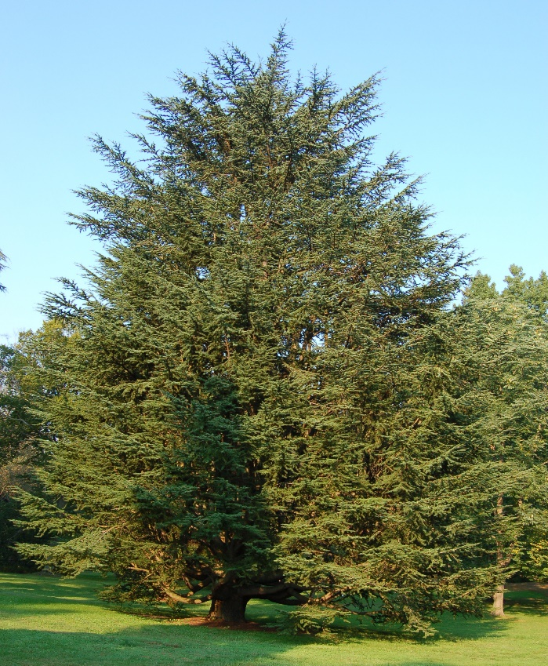*Cedrus atlantica*

*Cedrus atlantica*, commonly known as Atlas cedar, is an evergreen tree of the family Pinaceae found in the upper slopes of the Atlas mountain range in North Africa, namely Morocco and Algeria.[[1]](http://www.pfaf.org/user/Plant.aspx?LatinName=Cedrus+atlantica) It can grow up to 25m by 10m at a medium rate, prefers dry or moist soil and can tolerate drought.[[1]](http://www.pfaf.org/user/Plant.aspx?LatinName=Cedrus+atlantica)

*Cedrus atlantica* is often used for its essential oils extracted from the bark of the tree. These essential oils have been used for many different functions throughout history from their use in the process of mummification in Ancient Egyptian times to contemporary uses such as in massage to relieve muscle pain or as an inhalant oil to relieve respiratory conditions.[[2]](http://www.quinessence.com/blog/cedar-atlas-essential-oil) Its most common use in contemporary times is in aromatherapy but the oils can also be used in a variety of pharmaceuticals, in particular skin care products.

Cedrus atlantica - Photo (c)2007 Derek Ramsey ([Ram-Man](https://en.wikipedia.org/wiki/User:Ram-Man)) [[3]](https://commons.wikimedia.org/wiki/File:Atlas_Cedar_Cedrus_atlantic_Tree_1909px.jpg)